NEW A140 Dis-Eur- Czech Republic-Moravia-Dolní Věstonice-Human Head-26,000 BP

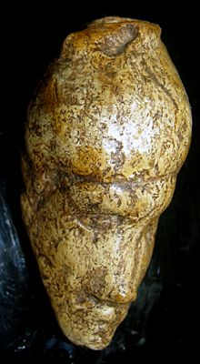 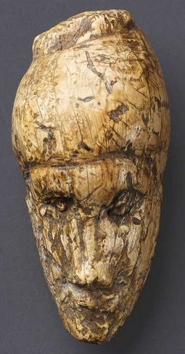 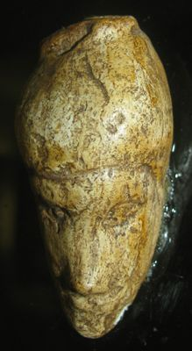

**Figs. 1-3.** Czech Republic-Moravia-Dolní Věstonice-Human Head-26,000 BP

**Formal Label:** Czech Republic-Moravia-Dolní Věstonice-Human Head-26,000 BP

**Display Discussion:** This mammoth-ivory human head from Dolní Věstonice, Moravia, in the Czech Republic, was found on the hill of Pollau 549 m asl (1,801 ft), and was dated to approximately 26,000 BP. This site has been a source of artifacts of the Gravettian period (27,000-20,000 BP). This human head is very unusual as it exhibits the effects of a stroke on the left side of the face that had befallen the real-life subject.

**Accession Number: A140**

**LC Classification:** GN772.22.C95

**Date or Time Horizon:** 26,000 BP C14 date.

**Geographical Area:** Czech Republic, Dolní Věstonice, Moravia, at the base of Děvín Mountain

**Geographical Area:** Czech Republic, Dolní Věstonice, Moravia, at the base of the hill of Pollau.

**Map, GPS Coodinates**: 48.88822 16.64369, 40° 26' 46" N 79° 58' 56" W

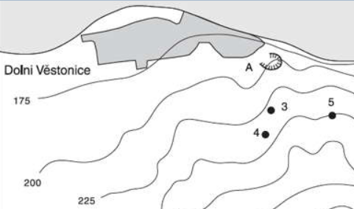

Fig. 4. Map of the Dolní Věstonice archeological sites.

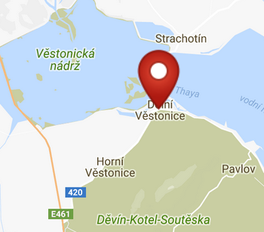 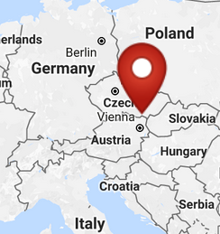

Figs 5-6. Maps of Dolní Věstonice rom http://latitude.to/img/latitude-logo.svg

**Cultural Affiliation:** Gravettian Period (27,000-20,000 BP)

**Medium:** original, mammoth ivory.

**Dimensions:   
Weight: original, unknown.**

**Provenance:** now in the Moravian Museum in Brno.

**Condition:** museum replica in resin.

**Discussion:** The stroke evidently transpired on the brain's right side, but affected the left side of the face, producing a mild paralysis, which resulted in the loss of muscle tone as recorded in this sculpture. In addition, there could have been complications involving vision and memory loss. The headdress of this individual shows no signs of a textile plait so it is suggested that it represents a leather cap which is pulled tightly on the head with a protruding bun on top. On the basis of the bun it has been inferred that this sculpture represents a woman, but this is not necessarily so. In any event, it represents a strikingly realistic and non-idealized sculpture of an individual with a medical problem and is totally unlike the other Dolní Věstonice carving of an abstract figurine (A130) with wide-spaced appendages suggesting a female pelvic structure.

It comes from one of the most famous Moravian sites, Dolni Vestonice, situated on the hill of Pollau at 549 m asl (1,801 ft). This site was excavated in the 1920s and again in 1947-52 (Klima 1963), and it has been a source of artifacts of the Gravettian period (27,000-20,000 BP). Remains of molluscs, spruce and pollen from the site suggest that it was occupied during a cold climate with a tundra environment.

**References:**

Trinkaus, Erik and Jiri Svoboda (Eds.) 2005.*Early Modern Human Evolution in Central Europe: The People of Dolní Vestonice and Pavlov* (Human Evolution Series). New York: Oxford University Press.